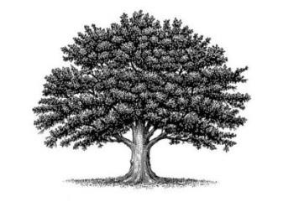

**Deed of Land Recording**

Baby’s Private Identity Code – **RE 909 660 416 US**

Terra Canada/ Canadian National Common Law Copyright and Trademark of Trade Name

On the ......... day of .................... in the year 2023, Anno Domini at the hour and minute of ................... a.m./p.m., a new baby was born on the land of .......................... County in the …..........................Province to the ...............................Family and was given the name

# …...........................................( enter Baby Name )...................................................

The private natural biological parents are: …......................................................, Father, born …....................on the land of the …................................................County, …...............................Province and …........................................................ Mother, born......................................................, on the land of …............................................._County , …..............................................Province [ ].

The family lives in the ..........................................County, .........................Province and keeps their mailing address In the Care of:

…............................................................................................................... [Postal Code].

This baby is their …....................... living child and ….......................................... son/daughter.

Witness Jurat

In Witness of these facts, before me, a Public Notary, appeared

Mary Jane Doe a private natural wo/man and did present proofs of their identity and was deposed and did swear to or affirm these facts from Without CANADA and did proclaim them under penalty of perjury and did sign this Deed in confirmation of all the above:

By: …......................................................................... , Witness

By: ............................................................... Notary My commission expires on: ….....................................................